**Xyz: Main Caveats**

* Cannot consider everything listed here in presentation
* Can only consider what we determine, and prove to be, most impactful/important things
* Key here is to have an unique considerations, that other groups are not considering, that may even have greater impact than the “obvious” considerations
  + Support it well, with graphs, graphics, and data.

**Main Ways - we can go about this**

* Regular Hibachi Eat-In
* Take Out / Delivery / Pickup
* Traditional Restaurant Format (No Hibachi Grill)
* Combinations of (1,2, or all 3 of above)

**Caution**

* Some restaurants had to permanently close because of covid?
* We need to understand why and take the reasons into consideration for our strategy for hibachi grill.
* Our revenues must justify the costs, if we can only have half our original revenue, we must somehow only have half of our original cost.
* <https://philly.eater.com/2020/5/18/21262156/philadelphia-restaurants-bars-closed-permanently-coronavirus-covid-19>
* <https://www.phillymag.com/foobooz/restaurants-closings-coronavirus/>
* (Legal Issues) <https://philadelphia.cbslocal.com/2020/07/10/black-taxi-golf-social-restaurants-closed-covid19-violations-philadelphia/>

**Random Ideas**

* Live Video of Chefs Cooking + Delivery to Home or Delivery to Table
* Add option to delivery food instead of eating in, or even complete transition to no eating-in, only pick-up or delivery, may need to optimize menu for that
* Adding extras tables just for seating, so that customers can be 6 feet away, do not have to sit so close to the grill.
* Adding shields around the grill and more space between grill and customer. Communicate with headset and speaker.
* Big problem is low industry margins, and biggest expenses in restaurant industry is labor and COGS, meaning if revenue or demand is lower than expected, the restaurant can quickly lose profit
  + <https://www.postandcourier.com/food/popularity-of-japanese-steakhouse-a-cultural-phenomenon-in-south-carolina/article_20eb97e2-3d89-11e8-9c61-9f1cdce083ad.html>
  + Reduce labor costs overall, but cutting costs
  + Increase worker cross-work opportunity and efficiency
  + Consider 24 hour reservation only eat-in policies to better manage inventory and demand
  + Reduce inventory overall, with transparency to clients
* Use a digital device to order for eat-in customers, one customer order, clean after every customer group.

**What data can we look into?**

* Health Safety Practices
* Financials (Revenue and Cost)
* Restaurant Industry (In General + Competition)
* Consumer Insights (What they value)
* Marketing

**Considerations Categories**

* Client (The restaurant)
* Customers
* Government / Regulations
* Employees
* Delivery (App + Own Employees)
* Competition (Other restaurants + experience eating places)
* Finances (Paying Employees + Costs)
* Interactions between Employees and Customers
* Interactions between Employees
* Interactions between Employees and Delivery
* Effects of Corona

**Safety Considerations**

* Customers (nuanced for each type of customer)
  + During their commute (any way we can address this)
  + Entrance
  + Rest Rooms
  + Seating
  + Pathing within restaurant
  + Interactions within their group
  + Interactions between customer groups
  + Interactions with employees
  + Sick consumers (check + reporting)
    - Feasible to check temperature? How to disinfect hands?
  + Use of protective equipment
  + Interactions with menus / reusable items
* Employees (Nuanced for each type of staff)
  + Staff entrance
  + Staff break / lunch time
  + Getting supplies/ingredients
  + During commute
  + Pathing in work space
  + Shared space
  + Shared resources/items/tools
  + Interactions with each other
  + Interactions with suppliers
  + Interactions with food
  + Interactions with delivery people (if applicable)
  + Interactions with customers
  + Sick employees (check + reporting + working guidelines)
    - Checking temperatures + washing hands extremely often
  + Cleaning/Disinfecting Tasks
  + Use of protective equipment
* Legal Considerations
  + With customers
  + With employees
  + With businesses in general

**Finance Considerations**

* Revenues
  + Likely purely from selling food
  + Margins differences for delivery and eating in?
  + Margin differences between menu items
  + How can we increase revenue
    - Number of customer groups
      * Average customers per group
    - Average spent per customer / customer group
* Costs
  + Health/Safety Supplies
  + Utilities & Rent (Negotiate/Subsidies?)
  + Labor (Cut hours? May be necessary)
  + Training (Safety + Cross-work)
  + Investments towards safety measures
  + Other?
  + What costs can we cut?
    - Mostly labor
    - Unprofitable expenses
* Marketing
  + Emphasize safety
  + Being able to meet consumer expectations even with safety measures
  + Advertising channels/medium
* Long Term Strategy
  + Long term Covid Plan
  + Assessment of safety/success
  + Financial projections into the future
  + Pricing at breakeven to maximize safety and employee retention?

**Culture Considerations**

* Relations within employees
  + Team Building Activities (Remote Ideally)
  + Support system during stressful times
  + Support system if employee gets sick
  + Carpool? Improve transit safety
  + Interactions during work
* Relations with employees (as the boss)
  + Being able to pay them
  + Providing Job Security
* Morale
  + What do employees value
    - Being paid + job security
    - Being safe
    - Not being too overworked
    - Being supported

**Delivery Considerations**

* Lowered Margins due to delivery fees or costs
* What food items are suitable for delivery
* Dealing with delivery people (mainly safety concerns)
* Hiring personal delivery people or through app?
* Reduced valuation proposition of hibachi (the experience)
  + How can we maintain experience
  + Use of video?
* Brand perception

**Restaurant Layout Considerations**

* Tables can easily be 6 feet apart, but need to consider rest rooms, customers moving around restaurant
* Need to also consider chef to consumer distance, chefs moving around, other staff moving around, such as waiters
* May need to optimize layout to minimize movement for each group of people, chefs, kitchen staff, waiters, customers

**Restaurant Menu Considerations**

* Supply of ingredients concerns
* Remove/Add items
  + Some items may not be feasible during covid
  + Other items may be more feasible
* Preparation complexity concerns?
* Pricing: Increase prices to increase margins
* Optimize menu for greater profitability?
  + Removing lower margin items? But what if population

**Competition Considerations**

* What does hibachi provide to consumers
  + Food
  + Experience
* Who are our competitors, what are they providing to consumers during covid, and what is their strategy
* How can we compete with their strategy

**Other Ideas or things to consider**

**Insights & Ideas from CDC Doc** (<https://www.cdc.gov/coronavirus/2019-ncov/community/organizations/business-employers/bars-restaurants.html>)

* Hibachi bar is considered highest/high risk due to distance issues
* Best corona prevention tactics include hand washing and staying at home
* Employees need to stay home and quarantine if sick
* Employees need to practice handwashing as often as possible
* Make sure there are enough supplies
* Make sure there are signs, instructional material (videos) for best practices)
* Ventilation is important
* Modifying table layout is advised to ensure groups stay 6 feetapart
* Water systems need to be safe to use (Legionnarie’s Disease)
* Limit Seating Capacity
* Find measures to avoid crowds of customers and employees
* Discourage using shared objects
* Self-Serve food/drink is advised against
* Physical barriers are advised
* Tape on floors is good for pathing
* High risk employees should be treated with greater caution
* Be wary of employee transit method, encourage methods that minimize contact
* Find measures to try and reduce employees/customers at any one given location at a time.
* Designate one staff member to be responsible for COVID concerns at all times
* Reduce staff at any given time, cross-train in multiple functions
* Communication systems that promote health and safety
* Accommodate time off strategies for sick employees
* Training employees for safety practices, recognizing symptoms
* Check employees for symptoms, even consumers

**What is the hibachi experience?**

**Lin: Main Ideas**

* **Overarching idea:** current business model is not resilient to geopolitical changes (i.e. COVID-19) and this is an opportunity to transform traditional small businesses into innovative industry leaders
  + Basically: scratch the trying to save its original business model
* **Who we are:** a premium customer and experience-first hibachi restaurant
* **New Business model** 
  + Key partnership
  + Key activities
  + Key resources
  + Value proposition
  + Customer relationship
  + Customer segments
  + Channels
  + Cost structure
  + Revenue Streams
* **Potential Solutions** 
  + Physical Restaurant (need to cut down number of tables)
    - Layout: private rooms and cubic style
      * **Private rooms:** install dividers, placed near the grill, can look into the grill and see the chef
        + Case study: local diners that are reopened (
      * **Cubic style**: sit every other seat, install dividers, live entertainment available
        + Case study: ichiran
    - Menu
      * Hibachi only items for lunch
  + Digital (can focus on non-grilled items- need to discuss the trade off since people might not have grills at home but want to cut down menu items to cut cost )
    - **Hellofresh:** mail / deliver the meats and people can home cook
    - **Airbnb Experience:**
      * Online cooking class, ingredients mailed to the participants
      * Party package available: 6 friends schedule to do a cooking class together
      * Partner with other small businesses (wine stores)
    - **Online restaurant** ordering system powered by [Shopify](https://www.shopify.com/restaurant-online-ordering)
      * Curbside pick up
      * Home delivery
  + Beyond COVID
    - Continue to be experience first

**Helen**

**Health and Safety**

* Problems:
  + Need to ensure employees are safe
  + Main concern = grill is too close to consumers (3.5 ft)
  + Legal issues
* Potential solutions:
  + Outdoor seating (what a lot of restaurants are doing right now)
    - Can also have some tables inside within 6 ft distance and some tables outside
  + Change layout provided
    - Move seats from the grill to 6 ft away, implement glass shields around grill so customers can still see
    - Section dining room into few sections, can still have grill but can also have small tv’s in each section to watch grill live
  + Reduce # of employees, let them alternate in teams

**Finance and Marketing**

* Problems:
  + How to pay workers, bring in revenue
  + How many chefs and wait-staff to re-employ? (reduced demand)
  + How to effectively market?
  + Business model for profitability?
* Potential solutions:
  + **Marketing**
    - Reach out to existing customers
    - Digital awareness campaigns / digital marketing to attain new customers
      * FB ads, google SEM etc
    - Sell meal kits, host online cooking classes, share recipes online
    - Discounts, promos
    - Sell merch, offer gift cards
    - Can host digital contests to share post on social media for chance to win promos, merch, gift cards etc
  + Partner w/ businesses or places that might need it
    - Can secure large ongoing catering orders
  + **Finance** 
    - Trim down menu to things that are best-selling, widen margins
    - P&L sheets
    - Funding from gov
    - Sell leftovers as ingredients?
      * Fish, rice etc

**Culture**

* Problems:
  + How to retain close relations w/ team during COVID
  + Explain to employers that their jobs are not stable
  + How to keep morale high
* Potential solutions:

**Other**

* Problems:
  + Want to potentially enter online delivery → get rid of in-person entirely?
    - How to transition experience-based business to “self-service” model
* Potential solutions:
  + Implement online delivery services + takeout
  + Gift cards

**Kevin stuff**

<https://docs.google.com/document/d/19BfDsRgP35Hze2WRex77dM6IiZ9Qq6GNV97Oe_tbMxU/edit?usp=sharing>

**Some data**

<https://docs.google.com/document/d/109RVjFouc9zVzHH_dEsGXJreFeWH4WxZKeA9pbe2nPY/edit?usp=sharing>

**Consolidated Consensus**

1. **Phases 1. Delivery + Online Experience + Live Stream, and then afterwards eat-in**
   1. **How to manage finances** 
      1. **Other employees can do other things, employed with us or not, word well**
      2. **Get rid of sushi - justify this,**
   2. **Phase Eat In**
2. **Digital Transformation Strategy**
3. **Experience**

Safety

* Obvious
  + Eat-In
    - (Appendix 10 page safety guide for eat-in)
    - Mask mandatory
  + Delivery/Pick-Up
* Non-Obvious
  + Temperature Checks at door
  + Call customers to check and track - keep list of customers - since reservations
* Phases
  + Delivery / Pick Up / Online Experience
    - Segment by worker
      * Hibachi chefs
      * Prep chefs
      * Waiters
    - Live Stream Chefs cooking
    - Menu Selection? Sushi
      * Financially bad?
      * Is not unique to hibachi
    - Frozen meal kits w/ recipes
    - Subscriptions, partnerships w/ other businesses
  + Eat In (Turn customers
    - *Hibachi for the experience*
    - When able to open, dictated by philly
    - Disposable everything, utensils, encourage venmo only, decentives for credit. Change more for non-disposable.
    - Reservation priority, walk-in extra fee, limited area for customers and employees, 3 tables only, extra table to maintain 6 feet, plus glass.
* Legal
  + When is able to open?
* Misc
  + Employees check at night too.
  + Ask for customer names and stuff
  + Signs for caution

Finance

* Reservations Only if Eat-In
  + Reservation deposit + Late Fee
* Less workers, less inventory
  + Cut loses
* BYO - Fee
* Make sure margins are positive
  + Revenue > Expenses
* Spending a lot more on safety and health
* Auto Add 20% Tip, optional decrease.
* Employees only paid via tip, boss make up to their hourly rate at original rate.
* Increase menu prices (demand thoe)
* Are there any subsidies for restaurants
  + https://www.sba.gov/page/coronavirus-covid-19-small-business-guidance-loan-resources

Marketing

* Ad credits from tech
* Membership
* Social Media Strategy?
  + How safe we are
  + Recipes
  + Virtual Tour
* Community first?
* Rebrand as more premium
* New culture
* Millennials culture
  + Less scared of covid

Culture

* Break even on profit, with some reserves for emergencies
  + Everything else towards retaining employees and safety
* Support Zoom Sessions
* Offering paid sick leave (some owners are offering sick leave from their own wages)

Delivery

* Use current employees, get some bikes (delivery fee)

Long Term Strategy

Insights

**Layout**





**Projections**

[**https://www.annualreports.com/HostedData/AnnualReports/PDF/NASDAQ_KONA_2017.pdf**](https://www.annualreports.com/HostedData/AnnualReports/PDF/NASDAQ_KONA_2017.pdf)

[**https://www.restohub.org/finances/financial-planning/understanding-restaurant-financials/**](https://www.restohub.org/finances/financial-planning/understanding-restaurant-financials/)

[**https://www.sec.gov/Archives/edgar/data/825788/000119312506061658/dex991.htm**](https://www.sec.gov/Archives/edgar/data/825788/000119312506061658/dex991.htm)

[**https://www.sec.gov/Archives/edgar/data/935226/000118811211001708/t70897_10k.htm**](https://www.sec.gov/Archives/edgar/data/935226/000118811211001708/t70897_10k.htm)

**35% cogs**

Reduce hours, when unprofitable

Likely before Noon and after 10pm

80 minutes (10 minutes down)

90%

9 Customers in 12 Hours *

25 customers

Avg Customer Group Size: 4

100 customers

$40

$4000

3 chefs (20 * 12 * 3) $720

3 waiters (8 * 12 * 3) $300

2 guy in the back ($200)

$1500

$1000

$1500 Eat-In

Eat-In: Profitable

Until 60% occupancy

Delivery

Avg Cost per Delivery $50

COGS + Prep Work + Cooking: $30

Delivery + Gas + Insurance: $5

$15 per delivery

Pro Chef

Philadelphia: 1.5 million

% rich enough to pay for this

50%

750k can afford it

Avg household size: 3

250k potential households

10% know about this, and are willing to do it

2,500 -> 50 per week in philly

5% of those ppl choose us (25)

Only $5500 profit per week

2 back up guys for delivery and other

2 guy for omakase

Omakase chefs are on call

For Couples

Avg # of people: 2

$150 each

$300 total

Pay chef $100 (he gets tip anyway)

Charcoal: $20

Food (normally $10 per person): $30

$150 profit per trip

For 4 ppl families

$150 (2)

$100 (2)

$500

Pay Chef: $100

Charcoal: $40

Food: $60

$300 profit per trip

**Revenue**

* Eat-In
* Delivery
* Pro-Chef

**Costs**

* Rent (fixed)
* Utilities
* Labor
* COGS

**Phase 1**

* Delivery
* Pick-Up
* Pro-Chef

**Phase 2**

* Eat-In
  + ($30)
* Higher wages
* More utilities

**Delivery**

* Drivers must make at least minimum wage including tip
  + Else Employer must make up
* Argument for owner drivers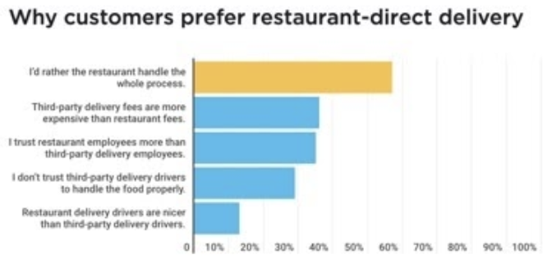
  + Lower margins
    - <https://montreal.eater.com/2020/4/27/21238331/delivery-fees-uber-eats-doordash-should-restaurants-hire-drivers>
    - <https://www.newyorker.com/culture/annals-of-gastronomy/are-delivery-apps-killing-restaurants>
  + Employ own people, own ppl first
  + Safety Standards easier to enforce
  + Faster Food Delivery to Guest, Better Experience
* What about delivery in general
  + Lots of other expenses
    - <https://pos.toasttab.com/blog/third-party-delivery-service>

**How much revenue are restaurants actually making?**

* <https://www.nrn.com/top-200-restaurants/how-24-restaurant-companies-performed-their-latest-quarters-coronavirus>
* Typical P&L:
  + Food and labor = 60-65% of total revenue
  + Occupancy costs = 8-10% more
  + Profit margin = 5-8%
  + Break-even point = must fill 80-85% of its seats
* COVID:
  + Delivery services charge 15-20% of overall bill
  + Restaurants that open dining rooms face patronage caps of 25-50% of capacity
  + Safety measures - additional cleaning, bathroom etc need costs
* <https://rallyforrestaurants.com/impact-COVID-19-restaurant-insights.html>
* **All states:**

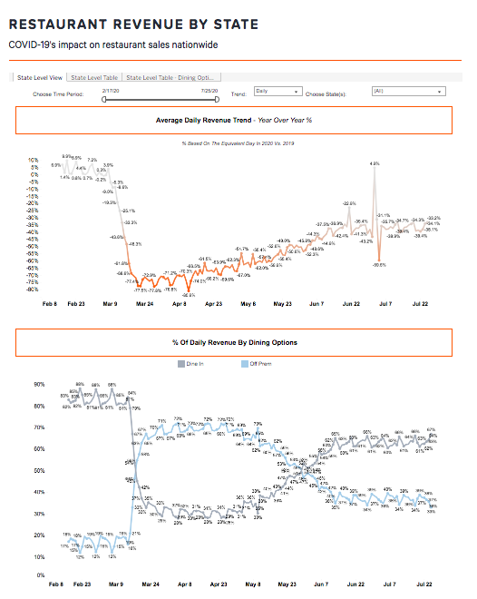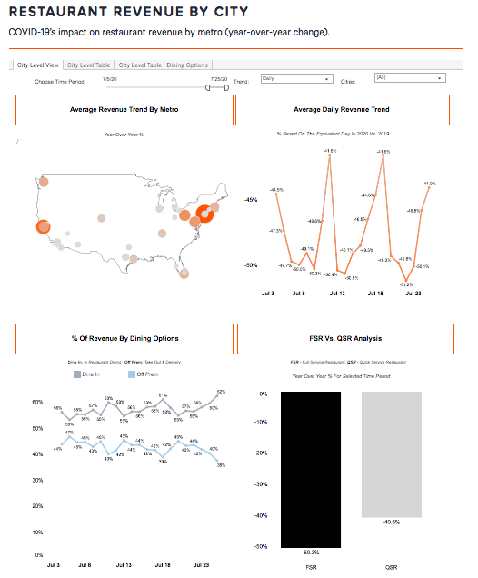

* **PA:**
  + 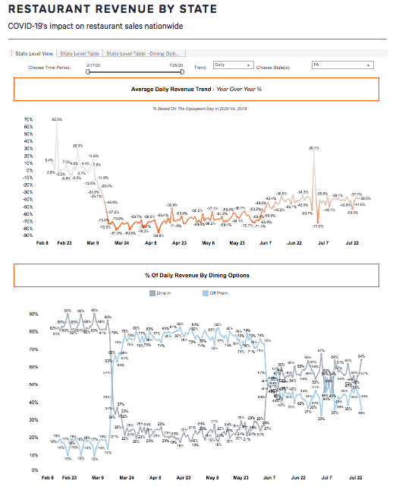

**Which restaurants are successful and why?**

* Restaurants that are successful:
  + Brands w/ strong pre-existing off-premise programs are thriving right now (since dine-in was forbidden for them before too)
  + Heavy emphasis on digital infrastructure
  + Store locations w/ drive-throughs
  + New, refined mobile apps
  + Delivery and takeout model
  + Comfort food that you can order in (ex. pizza)
  + Waive delivery fees, offer curbside service, launch family-meal packs
  + Large-capacity dining rooms = advantage for dine in
  + Chains heavily invested in tech for enabling third-party delivery or online ordering
  + Food prep rather than dining experience
  + Scaled back menus, prepared meals, meal kits, groceries, pre-made foods
  + Ex. Wingstop, Papa John’s, Domino’s, Popeyes
  + <https://www.eatthis.com/restaurant-chains-making-money/>
* A specific restaurant: Addo
  + Shifted everything to pickup and delivery
  + Use his own staff to make drop-offs rather than signing up w/ a profit-eating delivery service
  + Mix up his menu w/ diff offerings every day
  + Customers can order a pack of 3 diff meals to heat and eat at home
  + Customers can “pay forward” meals and the restaurant delivers it to a homeless shelter once a week
  + Social media marketing (videos of takeout cartons and bottles of wines ready for pickup)
  + Payment processing system where customers order everything ahead of time
    - Tock platform (diners can purchase their meals online) then just show up to eat/pickup at time they select
      * Helpful bc know how many diners will be in on a night so know how much staff, less food waste
      * Allows chefs to “treat their offerings like retail items”
      * Eliminates cash and on site point of sale transactions (w/ touchscreens and pens), contact-free handoffs
      * Can link this platform to social media posts
  + “Focus less on what you’re used to doing and more on what people need”
    - Think of things that would be nice if you’re sitting on the couch and need something
  + “Plan on underselling and over delivering”
  + People want to pick up early, eat at home at the same time they normally do
    - Most deliveries in late afternoon → shift into pickups in early evening
    - Sends 2 people in each delivery vehicle (driver and runner) who communicates w/ the guest
    - Everything is paid in advance including tips
    - Follow up w/ customers
    - Ask them what they would like, mix up what you’re selling and send it
  + <https://www.wired.com/story/restaurants-struggling-pandemic-eric-rivera-addo/>

**What price increase is reasonable? What demand is okay?**

* Look at profit margin v.s. food cost %
* Look at menu pre COVID and optimize it based upon margin and popularity
  + Modify recipe, increase price or remove completely
  + Reevaluate menu items to determine if they meet the min average margin needed to keep them on menu
    - Ex. if popular items are below the average margin then they should most likely be removed
* Margin is more important than food cost %
* Need to know theoretical food cost %
* Post COVID menus need to revolve around margin more than food cost % or popularity
* <https://joinposter.com/en/post/restaurant-food-cost-percentage-and-margin>
* Do market research (to understand customers), understand costs of product, know revenue target, know competition prices, know where market is headed
* Product price should vary depending on:
  + What the market is willing to pay
  + How your company and product are perceived in the market
  + What your competitors charge
  + Whether the product is “highly visible” and freq shopped and compared
  + The estimated volume of product you can sell
* When to raise prices:
  + Test new offers each month and watch sales volumes after making the change
  + Incremental price increases as to sudden drastic change
* When to lower prices:
  + Use it to garner market share, or have price sensitive product
  + Competitors are lowering prices
  + Offer less for the same price
* <https://www.inc.com/guides/price-your-products.html>
* Justifying price increase:
  + Raise the value, don’t lower the price
  + Increase the perceived benefits to balance the value provided
    - Friendlier customer service, improved restaurant atmosphere, fresher ingredients, faster service
  + Cut cost of dish by using less expensive vendor but similar and more affordable ingredients, decreasing portion size

**Slides outline**

Title slide (1 slide) (Kevin)

Overview (1 slide) (Kevin)

* Summarize the recommendations

3 main strategies

* Rebrand + Digital/Omnichannel experience (2 slide)
  + Curbside pickup / delivery (Livestream) (1 slide) (Kevin)
    - Premium Delivery
  + Rename + New menu (1 slide) (Helen via Canva)
    - Course meals (charge lot more)
    - [https://www.tripadvisor.com/Restaurant_Review-g188590-d697009-Reviews-Teppanyaki_Restaurant_Sanka-Amsterdam_North_Holland_Province.htmlza](https://www.tripadvisor.com/Restaurant_Review-g188590-d697009-Reviews-Teppanyaki_Restaurant_Sazanka-Amsterdam_North_Holland_Province.html)
    - Design first
* Omakase/Online classes
  + Rise of consumer interest in entertainment **(1 slide) (Lin)**
    - [Google search trend](https://www.thinkwithgoogle.com/feature/understanding-consumer-mindset-during-coronavirus/#top-level-footer) on consumer behavior
    - [Google search trend](https://www.thinkwithgoogle.com/consumer-insights/consumption-and-spending-habits-during-coronavirus/) on consuming more content together (i.e. “family friendly movies”, “watch together”)
  + More likely to try new brands
  + Consumers are not interested in dining out
  + Market as home travel / experience focused
  + Omakase vs. online classes
    - ~~Online classes~~
      * ~~More feasible, less creative~~
      * [~~Eataly~~](https://www.eataly.com/us_en/classes-and-events/nyc-flatiron) ~~(Italian food tasting market in nyc) is doing online classes)~~
      * ~~Success of Airbnb experiences~~
    - Omakase (2 slide) **(Lin)**
      * Tailor to the luxury market
      * [Business Inside](https://www.businessinsider.com/new-yorkers-paying-people-to-organize-closets-prepare-meals-save-time-2019-4)r: Personal helpers is no longer a service for the ultra rich
      * Previous top restaurant chefs (since layoff) are becoming [private chefs](https://www.businessinsider.com/day-in-the-life-of-private-chef-during-coronavirus-manhattan-2020-5#with-mask-and-backpack-on-he-heads-out-around-11-am-to-pick-up-groceries-before-heading-to-his-clients-apartment-in-soho-5)
        + Wealthy family hiring payoff chefs, [paying 2x](https://www.businessinsider.com/laid-off-nyc-restaurant-chefs-become-private-chefs-for-billionaires-2020-5)
      * Private chef market already exists but lack of Japanese focus
        + [Pricing](https://www.cozymeal.com/private-chef/12405/impressive-japanese-dinner): $300 for 2 people
      * Drawback: consumers are more value-conscious and less likely to spend on luxury goods → pitch that this is for the premium market
* In store operation (2 slides) (XYZ)
  + COVID-19 regulations: layout, safety measure (1 slide) (XYZ)
    - [McKinsey](https://www.mckinsey.com/industries/retail/our-insights/how-restaurants-can-thrive-in-the-next-normal) on recovery and safety measure (1 slide) (XYZ)
    - [McKinsey](https://www.mckinsey.com/business-functions/marketing-and-sales/our-insights/understanding-and-shaping-consumer-behavior-in-the-next-normal) on managing consumer behavior
    - [Mckinsey](https://www.mckinsey.com/business-functions/marketing-and-sales/our-insights/a-global-view-of-how-consumer-behavior-is-changing-amid-covid-19) on COVID-19 consumer sentiment
      * [Slide deck](https://www.mckinsey.com/business-functions/marketing-and-sales/our-insights/survey-us-consumer-sentiment-during-the-coronavirus-crisis) on spending behavior
    - [World Economics Forum](https://www.weforum.org/agenda/2020/05/coronavirus-covid19-consumers-shopping-goods-economics-industry): COVID-19 on consumer spending
  + Fees (waiting, tip)
  + Explain how in-store operations will work, reservations, justify number of employees, safety procedures, everything,
  + Explain how premium, pay chefs more
  + New menu

**1 Extra Slide**

Financial

* Profits go towards emergencies saving and retaining employees
* **Add some synergy**

Tactics recap / Culture (1 slide) (Helen)

* Implementation
* We try not to fire them (culture)
  + How train chefs etc

Appendix

* Market Size for Omakase
* Revenue Projections
* Safety Guidelines
* SWOT analysis
* 5Ps
* Positioning

New Menu (Eat-In)

|  |  |
| --- | --- |
| **Course Meals** | Dinner |
| 5 Course  *(3 entrees + veg + pancakes)*  *\*for the entire party* | $60 |
| **Entrees** |  |
| Vegetable Hibachi | $40 |
| Meat Hibachi *(*vegetarian sub available)* | $50 |
| A5 Wagyu Beef Hibachi *(*vegetarian sub available)* | $65  (N/A during lunch) |
| **Add-Ons** |  |
| Choice of Regional Sake *(*only if alcohol license approved)* | $20 |
| Seasonal Vegetables  *(Six Daily Vegetable Salad)* | $15 |
| Scallion Pancakes | $15 |

New Menu (Delivery)

|  |  |
| --- | --- |
| **Course Meals** | Dinner |
| **Entrees** |  |
| Vegetable Hibachi | 15 |
| Meat Hibachi *(*vegetarian sub available)* | 20 |
| **Add-Ons** |  |
| Edamame | 5 |
| Scallion Pancakes | 10 |